J.G.Harston
70 Camm Street
Walkley
SHEFFIELD
S6 3TR
jgh@arcade.demon.co.uk

The Planning Inspectorate
Room 3/26 Hawk Wing
Temple Quay House
2 The Square, Temple Quay
BRISTOL
BS1 6PN

PlanApp 08/20023/COM
163 Church Street, Whitby, YO22 4AS
Listed building consent for fascia sign

I am writing to support the original objection I made to this application, and to support Scarborough Borough Council’s decision to refuse permission and issue an Enforcement Notice.

163 Church Street (Crossgate Cottage) is a Grade II listed building originally built around 1635. The ground floor has been used as a shop at many times during this period; in 1901 Thomas Sleightholm (my great-grandmother’s cousin) operated a baker’s/confectioner’s there [Whitby Trade Directory, 1901]. During most of the 20th century the whole of the building has been used for residential purposes. My great-grandmother lived there from about 1920 to about 1951 and raised my grandmother there. My mother and one of her brothers lived the first few years of their life there. From 1951 onwards my great-grandmother, and then grandmother lived in 162 Church Street, next door.

The applicant wishes to have retrospective permission to place a wall-mounted facia sign on the first floor wall of the building. The dominant and distinctive character of shop signage in the Old Town area of Whitby is for any signage to be immediately above the display windows. In particular, shops along the Crossgate section of Church Street (Grape Lane to Bridge Street) have signage on the overhanging jettied timber framing. The following photo shows appropriate signage on 159, 160 and 162 Church Street.
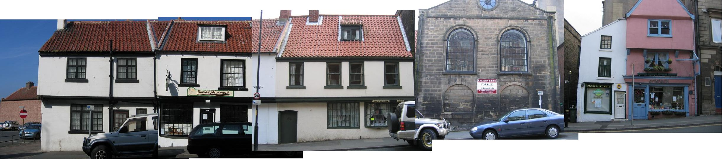
164-159 Church Street, Whitby May 2007 J.G.Harston mdfs.net

This has been the character of signage on these shops for many years. At no time has there been any wall-mounted signed (other than occasional For Sale signs, as currently on the Meeting House).

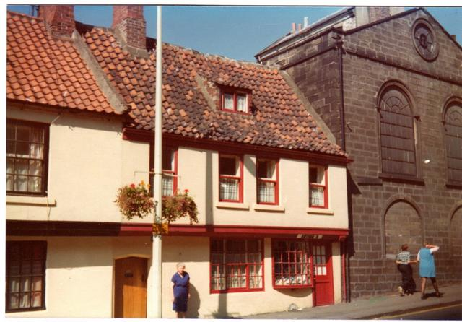

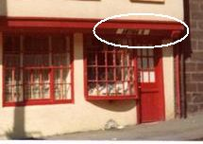

162 Church Street, 1980. Photo from personal collection.

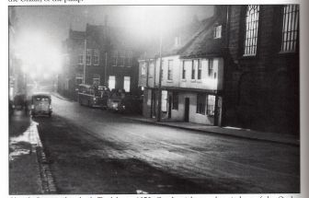

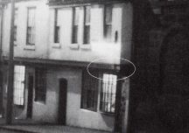

164-161 Church Street, 1970. Around Whitby, D.G.Sythes, 1997.

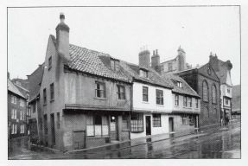

164-161 Church Street, 1960. Whitby in Times Past, Alan Whitworth, 2005.

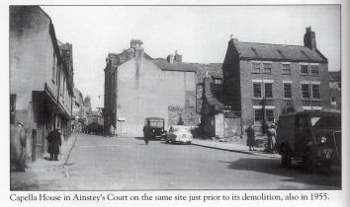

164-161 Church Street, 1955. Whitby, The Second Selection, D.G.Sythes, 1999.

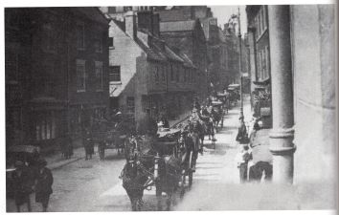

164-161 Church Street, 1905. Then & Now Whitby, Colin Waters, 2004.
Thomas Sleightholm’s baker’s shop can be seen at 163 Church Street, and Franklin’s Coffee Shop can be seen on the immediate left of the picture.

The applicant has been granted permission for the overhanging sign. While none of the shops have had overhanging signs, I believe that granting permission for this sign is appropriate. The circular “pie shop” sign is appropriate for this shop. It is of an appropriate character for a pie shop, and is similar to the type commonly seen in old images of pie shops, illustrated works of Charles Dickens and episodes of Blackadder III are well known examples. If the shop ceases to be used as a pie shop, the sign should be removed, and any future signage must be subject to a further application.

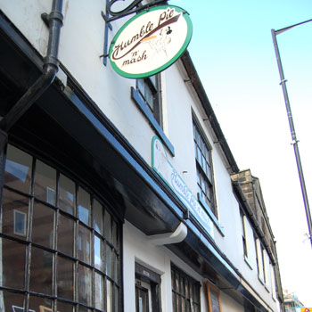

Overhanging sign, 163 Church Street.

Just immediately nearby to 163 Church Street, Franklin’s Coffee Shop at probably 166 Church Street had an overhanging sign. Around the corner on Grape Lane, the Britannia Inn had an overhanging sign. These buildings were demolished in the 1950s and have been replaced by the Tin Ghaut car park. I have been unable to find a suitable photograph of the Britannia Inn, but Franklin’s Coffee Shop can be just seen in the 1905 photograph above.

In summary, I consider the use of a facia sign to be out of keeping with the historic character of this area of Whitby and support the Council’s decision to refuse a fascia sign. The applicant should remove the facia sign, and be allowed to replace it with a sign mounted on the overhanging jetties. The overhanging sign should be allowed to remain.

J.G.Harston

