ELECTRON
SECOND
PROCESSOR

Speed up your Electrons and watch your memory expand with a 6502 second processor, designed by John Wike with Electron owners in mind.

This article describes the addition of a second processor board to an Acorn Electron, making 30K bytes of RAM available to BASIC (60K to machine code), and giving an
increase in processing speed of up to three times. The hardware will be described this month and the software next month, together with a complete assembly listing.

What about the others?
Although the term 'second pro-cessor' is usually associated with Aorn and their 'Tube' system, multiprocessor designs are found in several microcomputers in the business and scientific markets. Even the Sinclair QL contains two microprocessors, one to handle input/output and the other to do the computing. So, although the circuit shown here is designed specifically for the Acorn machines, the concept is generally applicable.
It is relatively straightforward to design a circuit board with a pro-cessor and some RAM on it, and to interface it with an existing computer system. The real problem is the software, machine code of course, to handle the new hardware.
Benchmark Mode 6 Mode 0 E2P (BBC)
1 0.93 2.11 0.68 0.8
2 4.01 9.35 2.99 3.1
3 11.54 26.97 8.43 8.3
4 12.27 28.86 8.95 8.7
5 12.85 30.15 9.37 9.1
6 19.51 45.72 14.35 13.7
7 30.09 69.88 22.24 21.3

Table 1 Benchmark timings for the Electron with and without E2P.
As the host machine probably has the screen RAM within its memory map, it must be assumed at it will retain the input/output handling functions. This means that the language (usually BASIC II) operates in the second processor.
It is necessary to know how to intercept the input/output routines (PRINT, INPUT, SAVE, LOAD, etc.), so that the data will be transferred to or from the second processor's memory instead of the host's. Routines can then be written to reside in each processor's memory and allow them to communicate with each other transparently, so that the user will not be aware of any difference in operation from the basic machine.
All this sounds involved, but given a machine that is well supported by reference material and ROM listings, or your own skill at disassembly, it is by no means impossible. So if you are interested have a go!

2P or not 2P?
The owner of an Acorn machine does not need to worry about the foregoing because this article will cover all the ground. He or she will however have to decide whether it is worthwhile adding a second processor to the system. There are several advantages to balance against the effort involved:

Speed
The benchmark system has gained widespread acceptance as a qualitative assessment of the processing speed of a computer. For a full discussion of benchmarks the reader is referred to the February 1985 edition of Computing Today. Each test consists of 1000 iterations of specific instructions, the times for which are given in Table 1. Also included for interest are the timings for the BBC computer, taken from the Computing Today article. In Mode 6 the unexpanded Electron is approx-imately 50% slower than the BBC, and in Mode 0 it is 250% slower! With the E2P board fitted it is approximately the same as the BBC in all modes.

Memory
The display memory in the Electron can consume between 8K of RAM in Mode 6 and 20K of RAM in Modes 0, 1 and 2. Add to this the 3.5K used as operating system workspace, up to 1.5 K for user-defined characters and an extra 3.75K if the Plus 3 disc drive is fitted, and out of a total of 32K there might only be 3.25K available for programs. The E2P board contains 64K RAM, 30K of which can be used from BASIC whatever the configuration. Machine code programs can use a massive 60K.

Processor
The first requirement of the design was that the hardware and software should react with the Electron operating system in the same way as the official 'Tube'. This is a ULA with eight bidirectional registers, addressed at FCE0h to FCE7h, of which seven are used by the support software and only one, at FCE5h, is accessed directly by the operating system for data transfer during, for example, LOAD and SAVE. So the circuit must detect accesses at FCE5h and interrupt the second processor to allow it to pass the required data. The other registers can be at any convenient address, since they have their own support software.
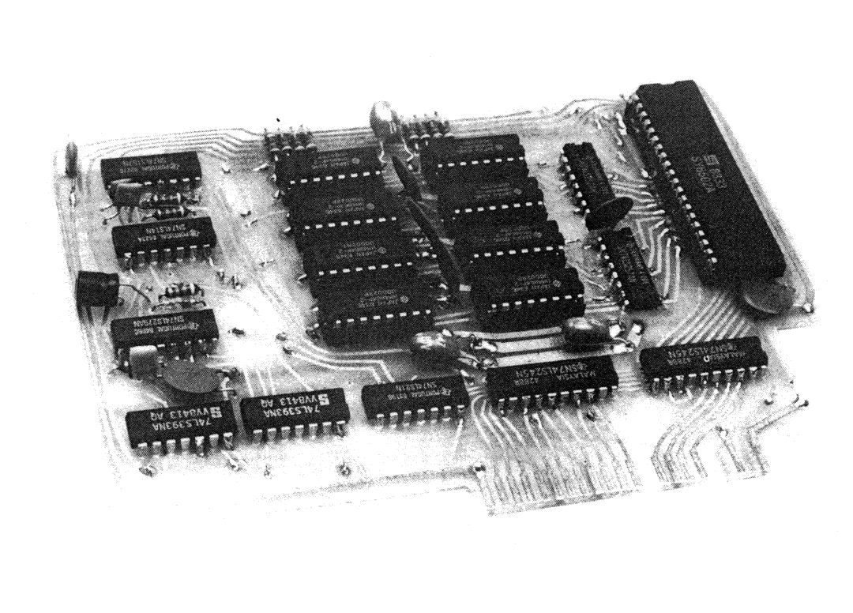

The author’s
The author’s prototype second processor board (some changes have been made in the final version).
The only storage device on the board is the RAM. The top 256 bytes of that are accessible to the Electron, so that several locations can be used as the bidirectional registers. Also, as this is the area where the 6502 goes at Reset, the Electron can control its reset and transfer sufficient code there beforehand to allow it to "boot up'. After that the rest of its operating
system can be sent via the data byte at FCE5h.
When deciding where in the Electron memory map to locate this 256 byte block, it was remembered that sideways ROMs are given the opportunity to initialise themselves at BREAK and to declare themselves during the *HELP command. The block is therefore addressed as a sideways ROM and the first eleven or so bytes are taken up with the necessary data for it to be recognised by the operating system. They also contain a jump instruction so that the 'ROM' software can be in the main program in the Electron RAM.
In order to refresh the dynamic RAM the processor is interrupted every 1ms and a specific routine scans 128 bytes in 64us. On alternate interrupts it scans another 128 bytes to include all the rows in the RAM. This results in a time overhead of 6% which is considered acceptable by the author. Because the refresh is software controlled there is no facility for a hard reset of the processor. Instead, the 'sideways ROM' routine issues an initialisation request on BREAK.

Interfacing
The board is designed to slot into one of the cartridge sockets on the Plus One interface unit, which provides some of the address decoding. For those people without a Plus One, a circuit is shown allowing connection to the basic Electron.
Current consumption of the board is about half an amp, which the author's machine was able to cope with. If a lot of other devices are drawing power, it may overload the
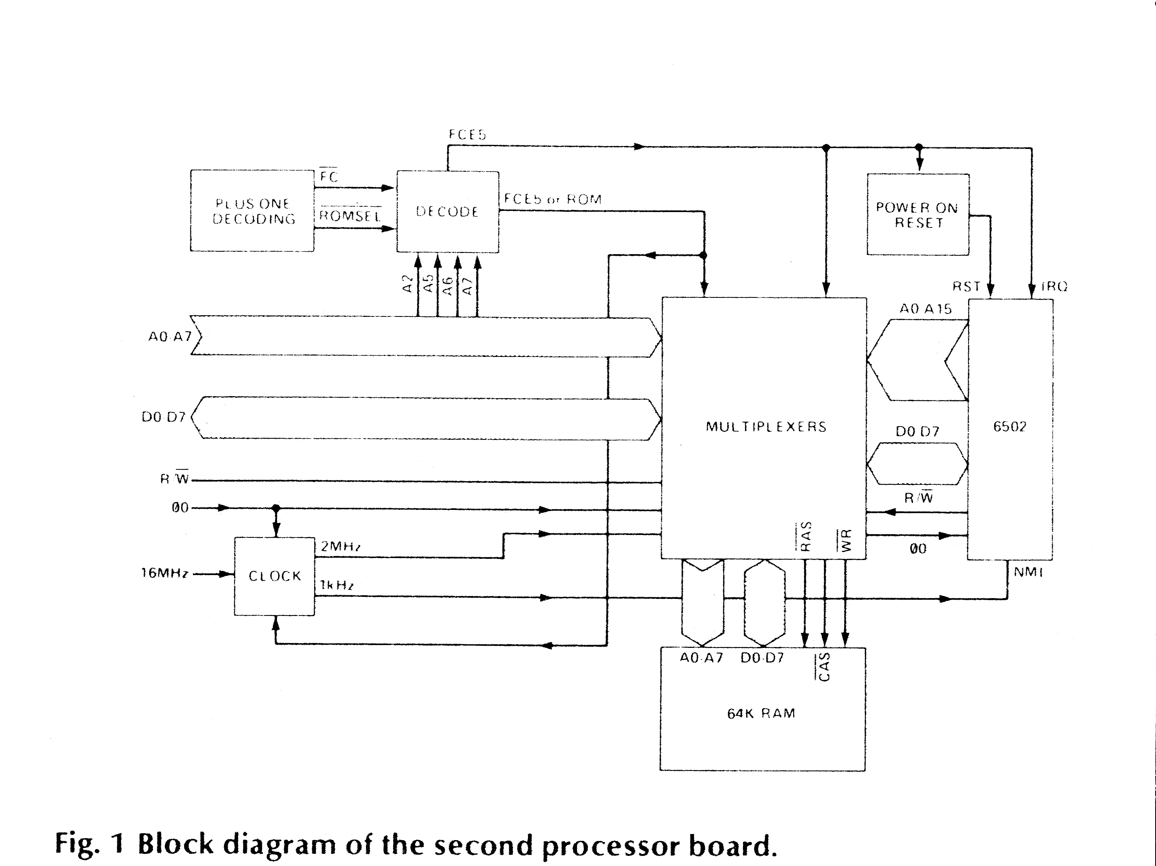
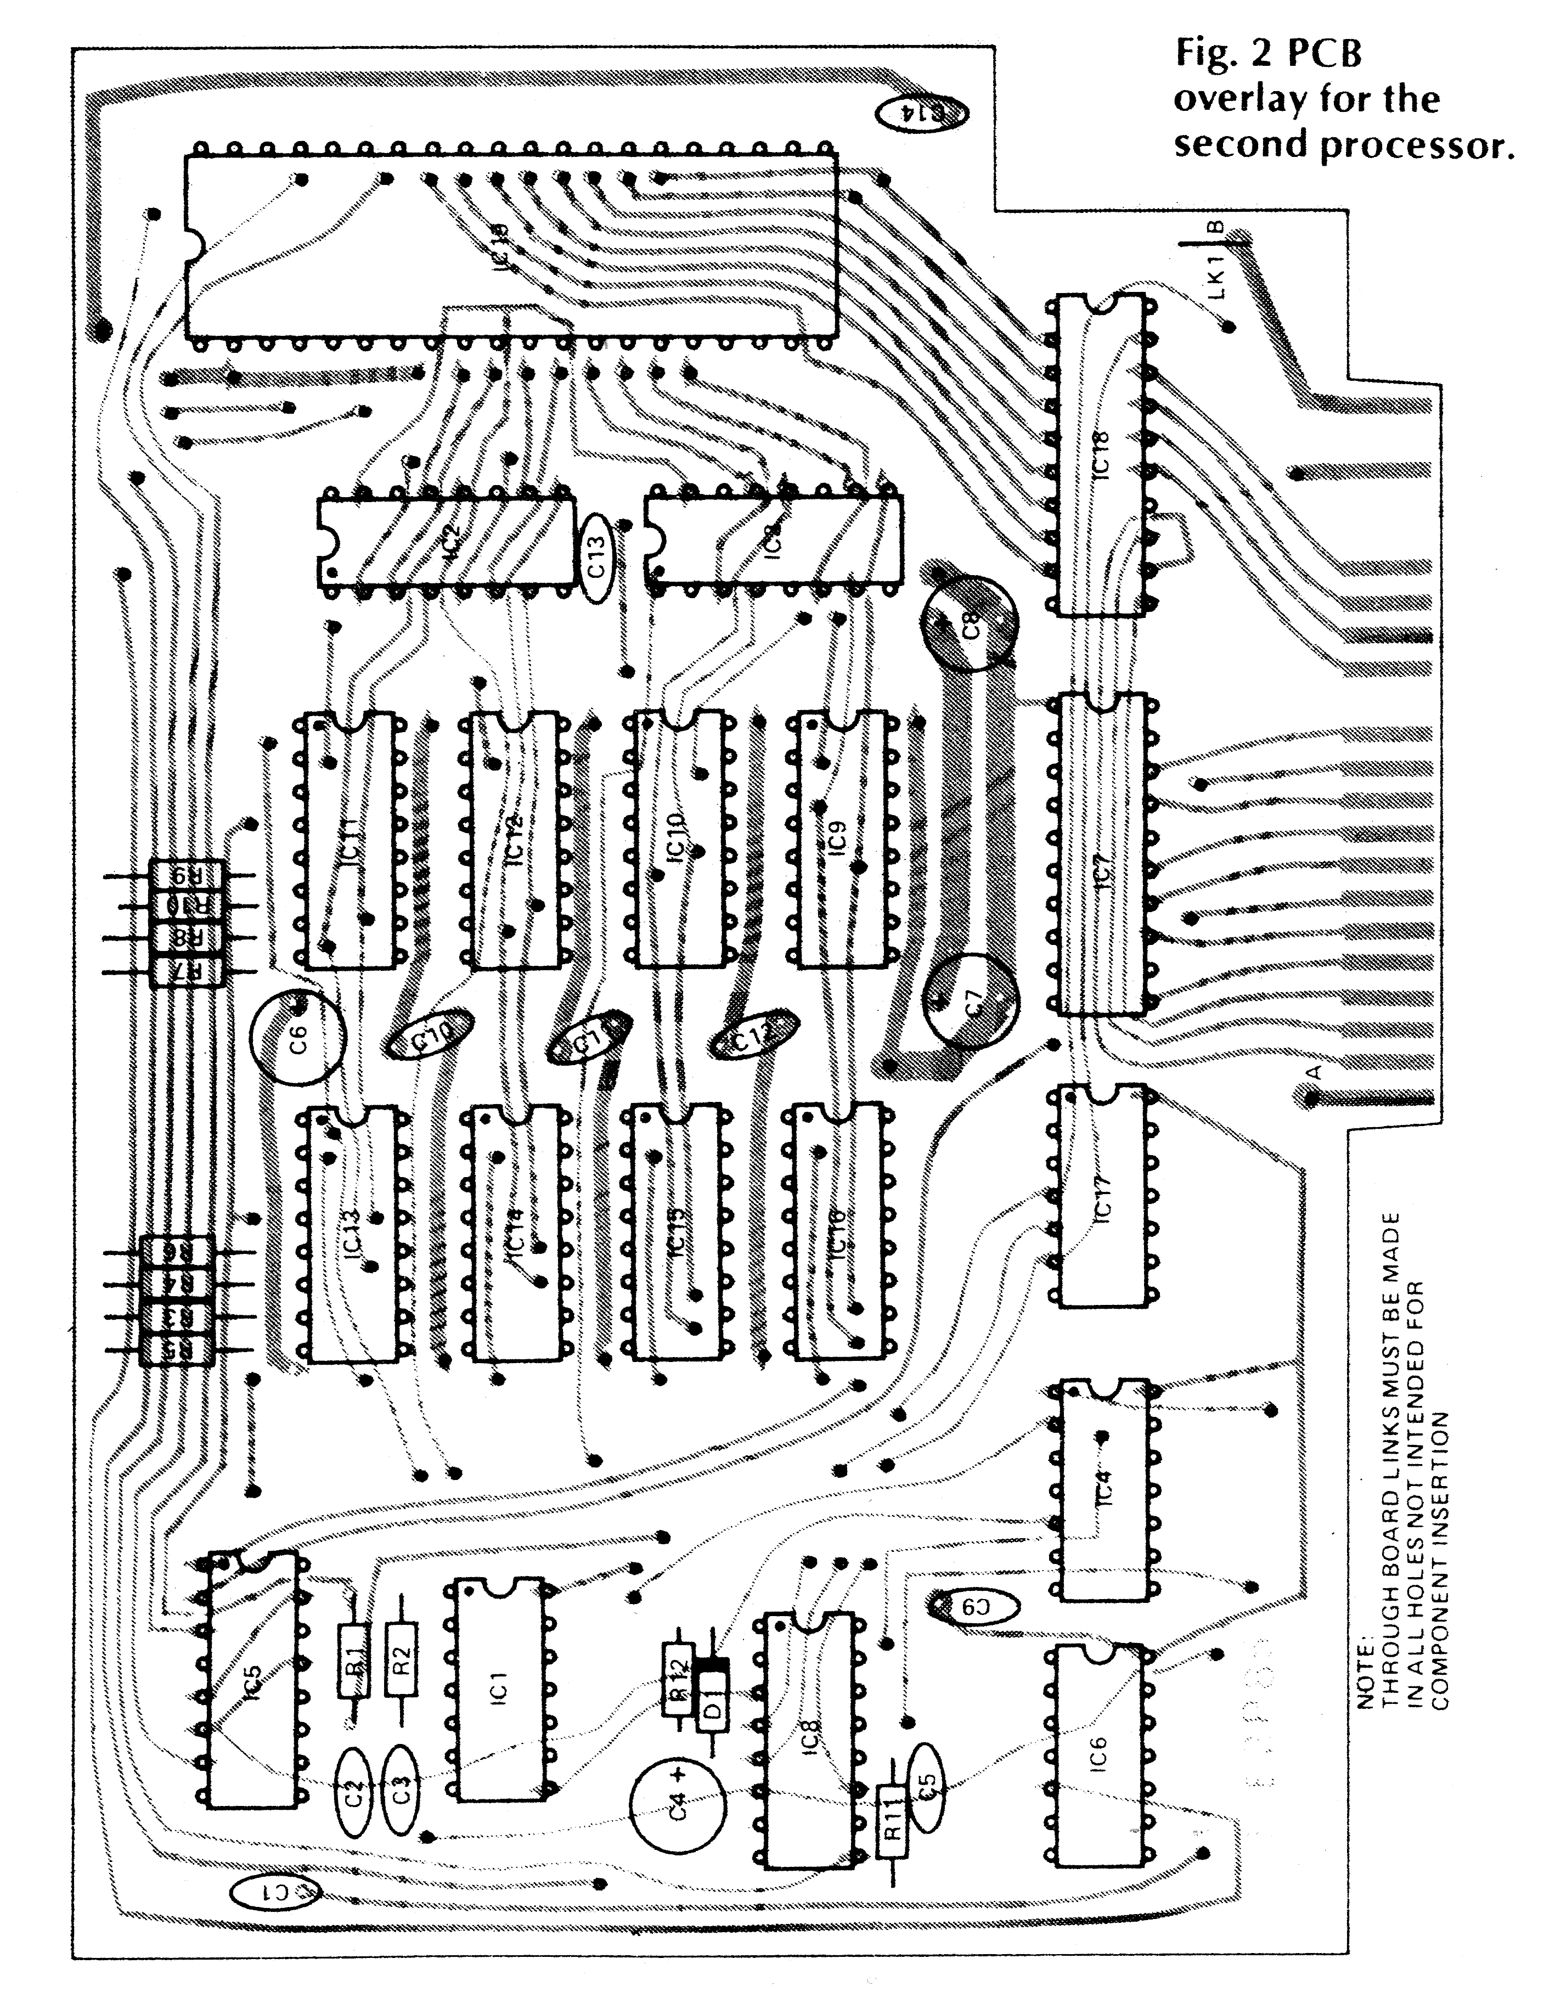

supply. A link (LK1) is provided to disconnect the 5 volt line from the edge connector and an alternative supply can then be connected to the board.

Construction
Construction of this project is straightforward but you are recommended to use a fine tipped soldering iron, and to check the board closely to see that no stray bits of swarf or solder are shorting tracks.
As this is a double sided PCB and is not plated through, the first thing is to insert all the links and solder them on both sides of the board. Take special care not to miss the ones underneath ICs as these will be impossible to fit afterwards.
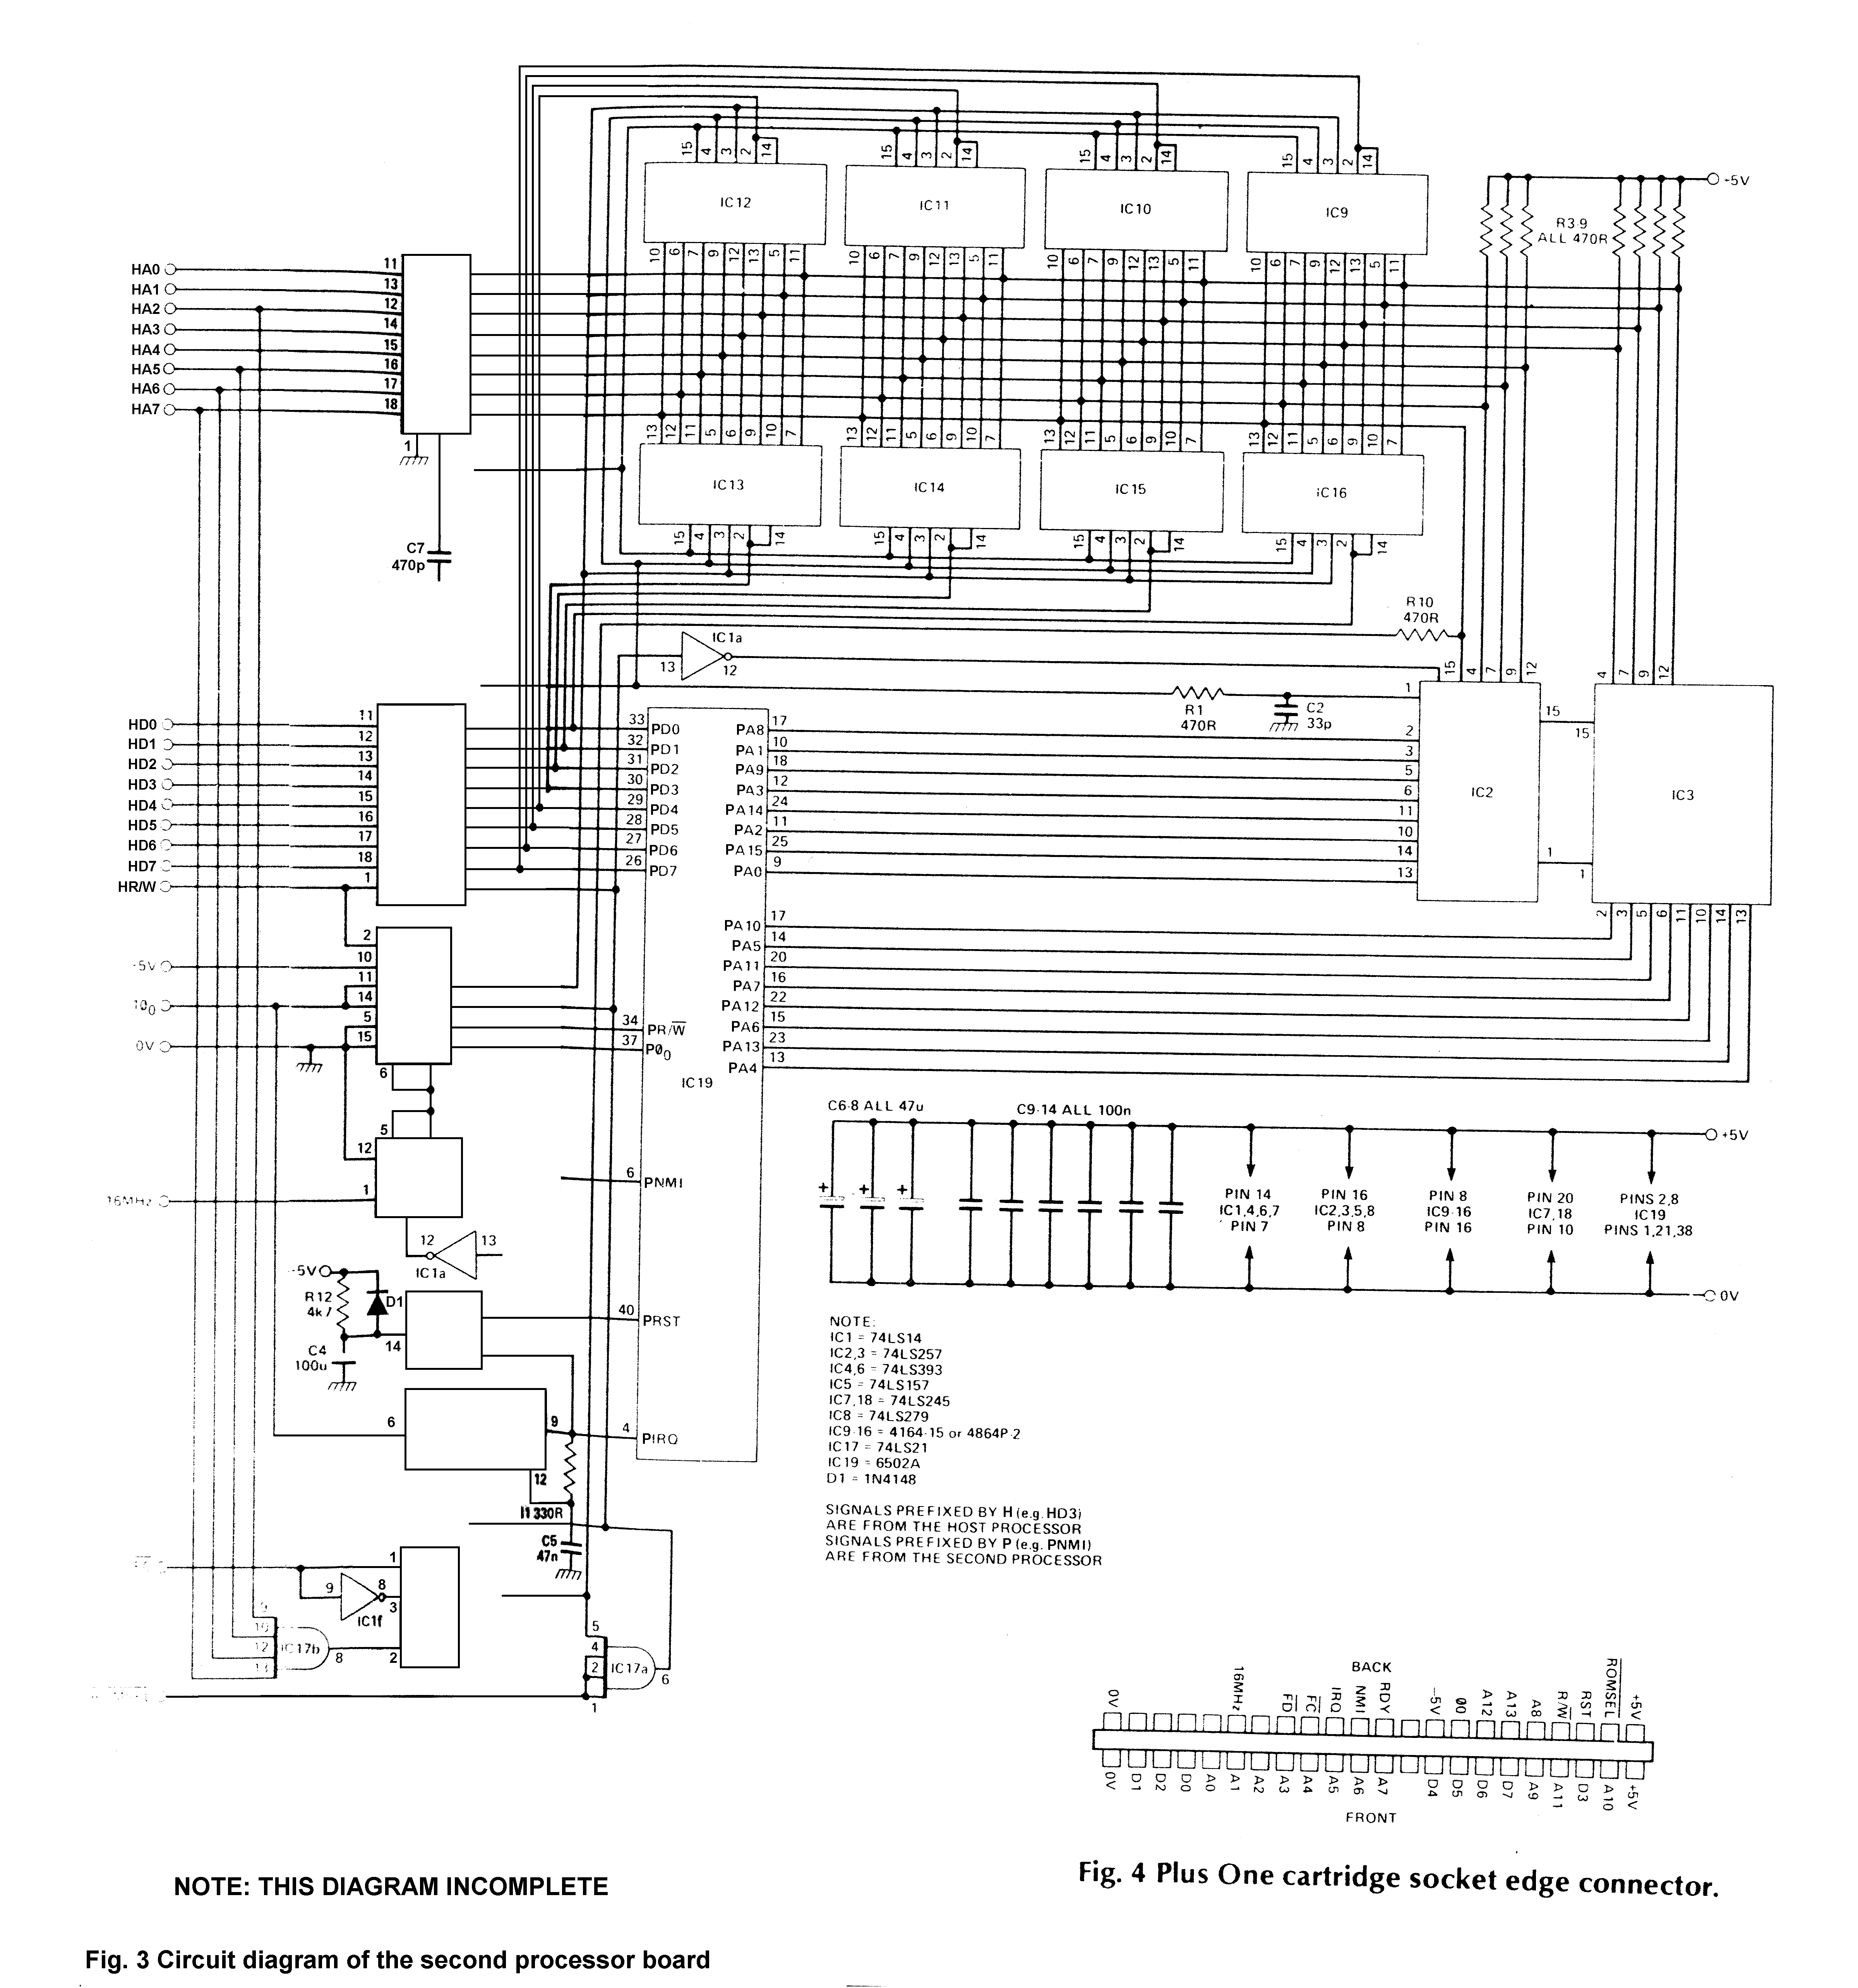
Next fit all the ICs except the RAMs and the processor, soldering their leads on the bottom, top or both, as necessary.
Next fit the resistors, capacitors and diode. Some of these components need to be soldered on both sides of the board.
Now fit the sockets for the RAMs and processor. Use insulating tape to protect the through-board links before inserting the sockets.
If you intend to power the board from the Electron's 5 volt line fit the
link LK1. Otherwise, connect the external supply wires to points A (0 volt) and B (5 volts).
Finally, insert the RAMs and processor into their sockets.
If you do not have the Plus One unit you will now have to construct the interface circuit. This could be done on Veroboard and then connected, along with the second processor board, to the Electron with a short length of ribbon cable and a 25 pin double-edge connector.

HOW IT WORKS

The second processor is reset at switch on by latch IC8a with C4 and R12. Diode D1 ensures that C4 will be discharged quickly at switch off.
IC8 is a quad S-R latch with Set overriding Reset. Sections c and d are used to provide extra AND functions.
Decoding of the host processor address bus is performed by IC17, IC8d and IC1f. When either the sideways ROM or FCE5h are accessed, the output of IC17a will go low. This signal enables the data bus buffer, IC18. It also disables the second processor address multiplexers IC2 and IC3, after being inverted by IC1a, and it operates the control line multiplexer IC5. IC5 determines which processor's R/W and clock signals will be applied to the RAM - when Pin 1, select, is low the second processor clock and R/W times are effectively disabled.
The second processor 2MHz clock is generated by IC4 divifing down the master 16MHz oscillator. Further division takes place in IC4 and IC6 to give the 1ms NMI signal. Note that as the processor only responds to negative edges there is no need to provide short pulses.

Setting up
Before switching on, check the board very carefully for shorted tracks and the orientation of ICs, diodes and electrolytic and tantalum capacitors. To ensure that the Electron will will not be damged check every contact on the edge
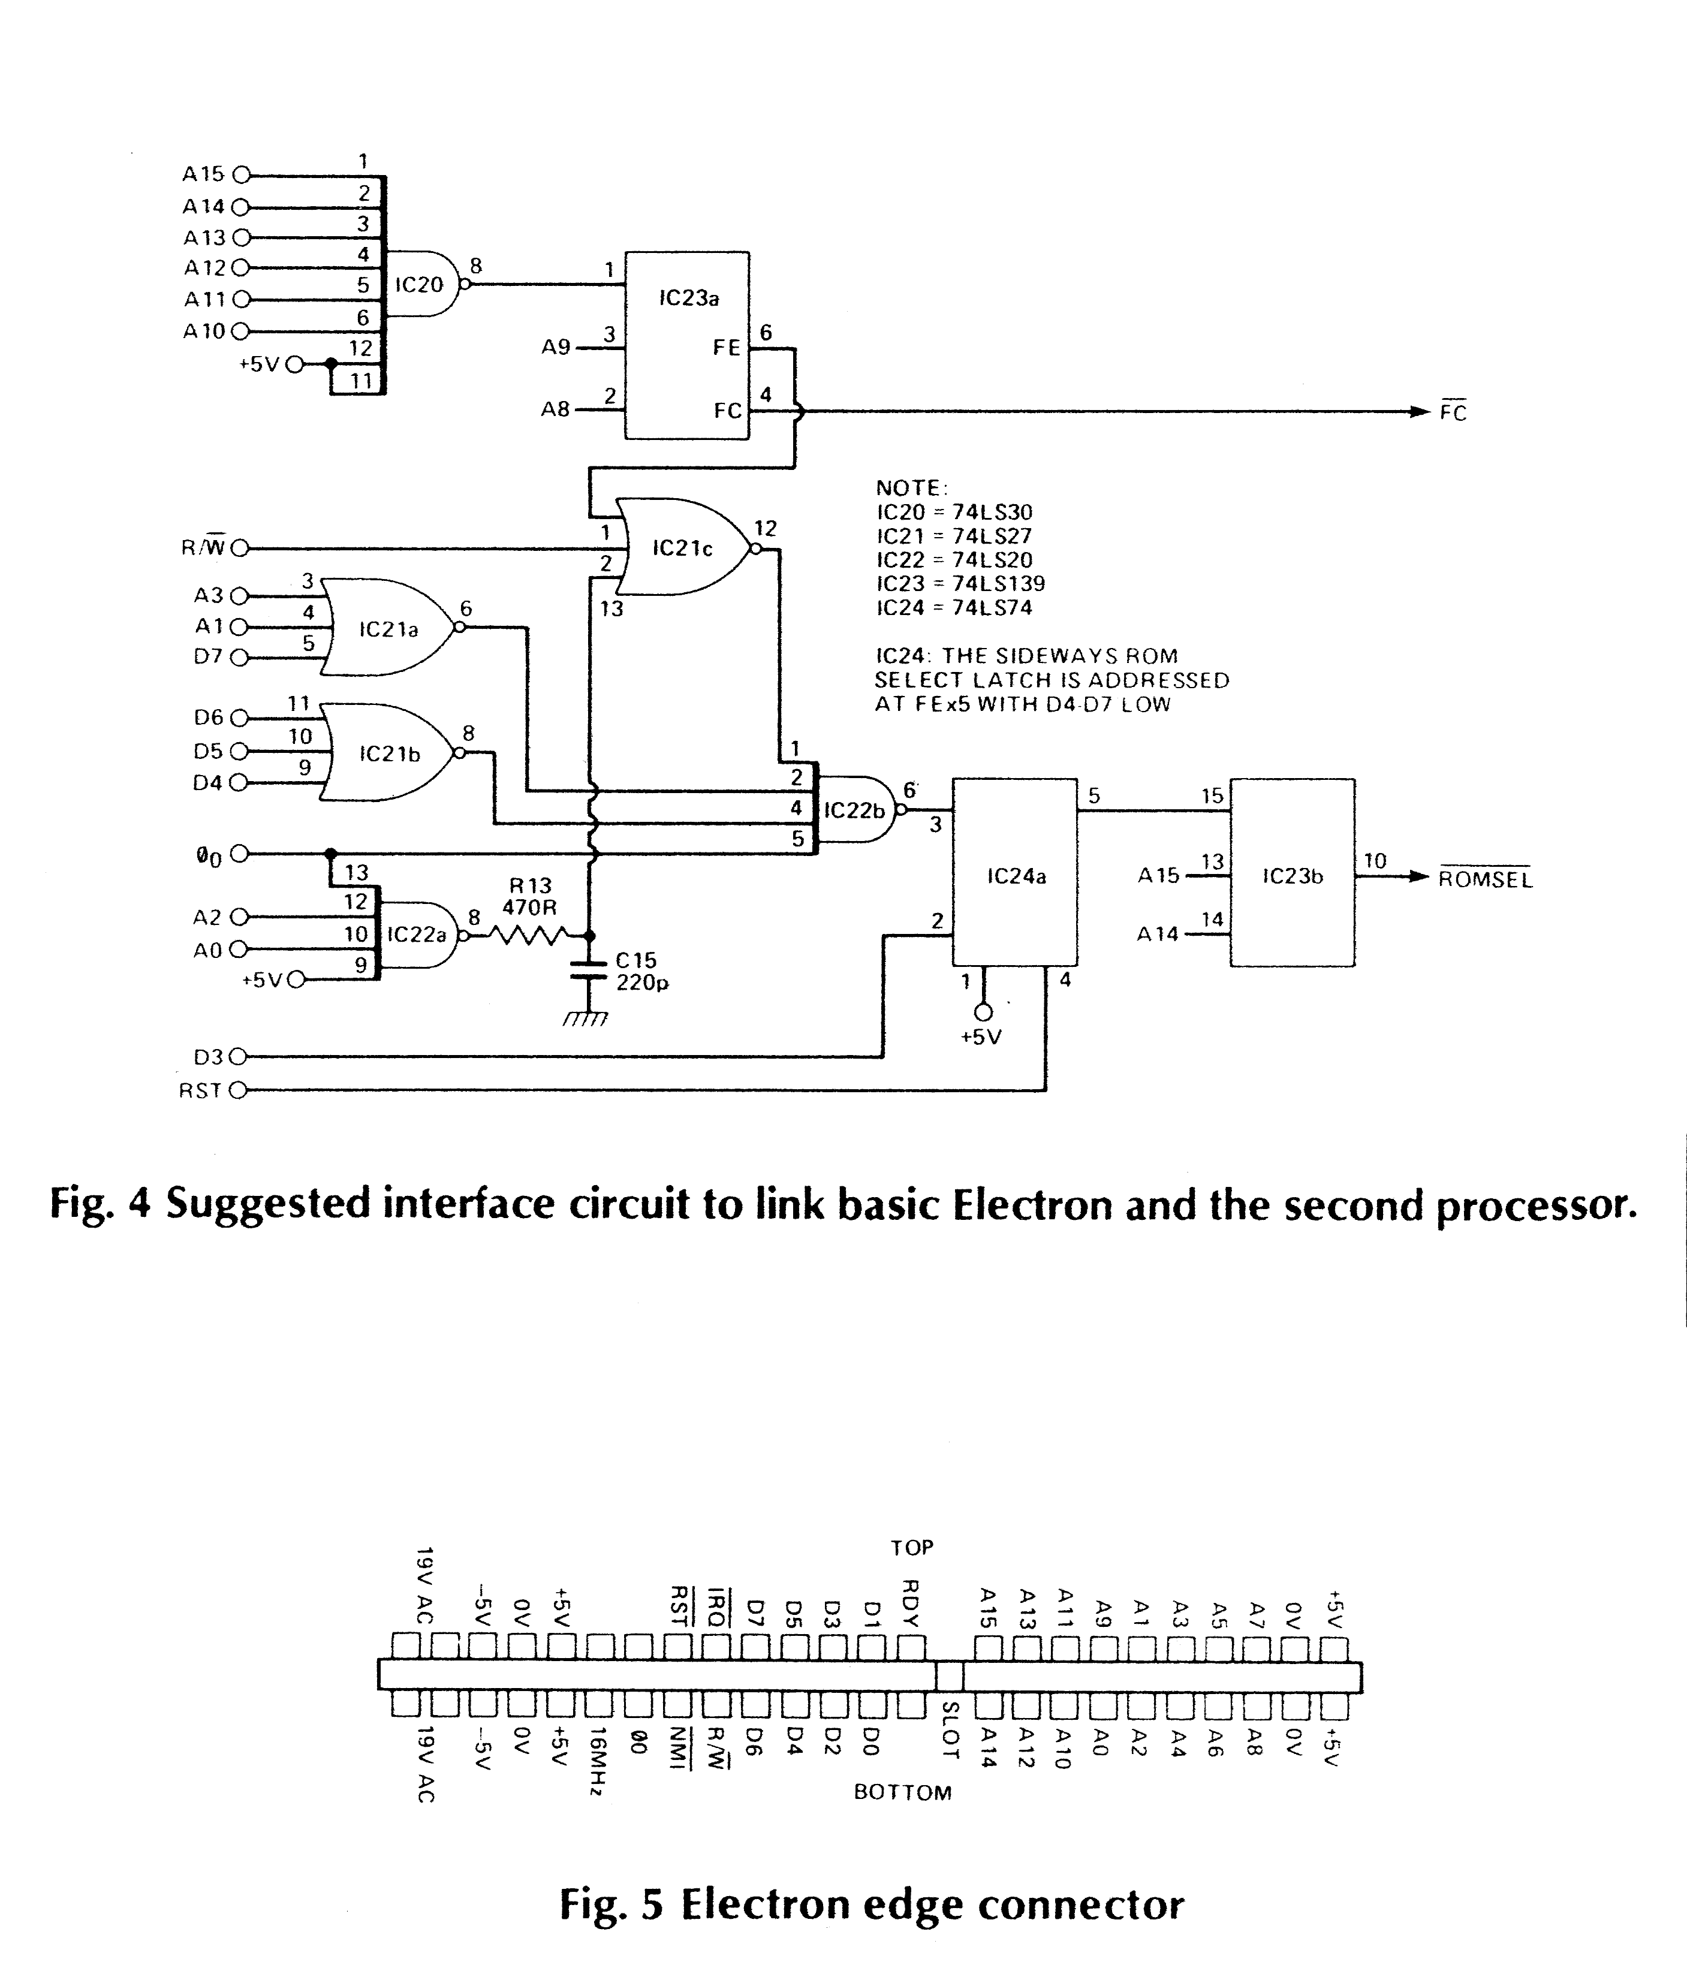
connector with a meter for shorts to either the 0 volt or 5 volt supply
lines.
Connect the board and switch on. You should get the start-up message as usual. If not, then switch off and check again for shorts. If you can get hold of a double-beam oscilloscope, connect a probe to pin 9 of IC8 and enter and run the following program:
10 A%=?&FCE5:GOTO10
You should see on the 'scope a negative going pulse 15ms wide. If it is a different width adjust the values of R11 and/or C5 to get it as close as possible.
The output of IC17a is combined with the host processor clock in IC8c, which triggers the 15us IRQ monostable IC8b. The monostable is inhibited during ROM selection by the input at pin 11 so that it will only operate during an access at FCE5h. The monostable output is also fed to IC8a to clear the second processor reset.
The output of IC8a goes via IC1b to set the second processor cock in phase with the host’s during host access. Because the clocks are in phase, the control multiplexer IC5 can be guaranteed to switch when they are both low.
Tri-state buffer IC7 with resistors R3-R10 performs the address multiplexing function for host processor addresses. It is enabled during the first part of a host access to give the row address for the RAMs, then it is disabled and the resistors provide the column address. If it is a ROM address, IC8d output will be high and page FFh will be accessed. For address FCE5h, IC8d will be low and page FEh will be accessed.
The RAS signal to the RAMs is provided by IC1c and the CAS signal by IC1d and IC1e from the delay circuit R2-C3.
Now connect one input of the scope to IC1 pin 1 and the other input to IC1 pin 6. The negative going edge of the signal on pin 6 should occur between 120 and 150ns after the positive going edge at pin 1. Adjust R2 and/or C3 as neccesary.
Before trying the system in earnest you will have to switch off then on again in order to hard reset the second processor.
The necessary software will be included in next month's article, but

in the meantime a copy of the assembly code is available on tape from the author. Alternatively, if you send a Plus Three disc it can be stored on that together with the

PARTS LIST

INTERFACE

RESISTOR
R13 470R

CAPACITOR

C15 220p

SEMICONDUCTORS
IC20 74LS30
IC21 74LS27
IC22 74LS20
IC23 74LS139
IC24 74LS74

MISCELLANEOUS
Veroboard, 22-way double sided socket to fit E2P edge connector, 25-way double sided socket to fit Electron edge connector.

machine code as a !BOOT file so that pressing shift-break will automatically boot in the second processor. See Buylines for details.

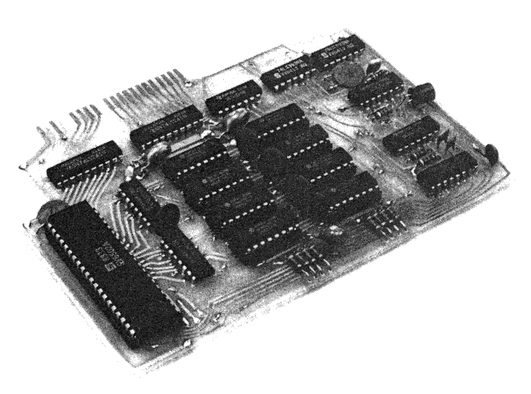

BUYLINES

PARTS LIST

MAIN BOARD

RESISTORS (all 1/4 watt)
R1,2,3,4,5,6,7,8,9,10 470R
R11 390R
R12 4k7

CAPACITORS
(all ceramics unless stated)
C1 470pF
C2 33pF
C4 100uF electrolytic
C5 47nF
C6,7,8 47u 10V tantalum
C9,10,11,12,13,14 100nF

SEMICONDUCTORS
IC1 74LS14
IC2,3 74LS257
IC4,6 74LS393
IC5 74LS157
IC7,18 74LS245
IC8 74LS279
IC9,10,11,12,13, 4164-15/4864P-2
14,15,16
IC17 74LS21
IC19 6502A (2MHz)
D1 1N4148

MISCELLANEOUS
40 pin DIL socket, 8x16 pin OIL sockets, wire for links.

All the components are available readily from advertisers in ETI. The PCB and software are available from the author, John Wike, at 9, Lon-y-Garwa, Caerphilly, Mid-Glamorgan. The price of the PCB is

£12, software on tape is £3.50, and on your disc £2.00, inclusive of postage, if you send a disc please state whether you wish to have the !BOOT file put on it.

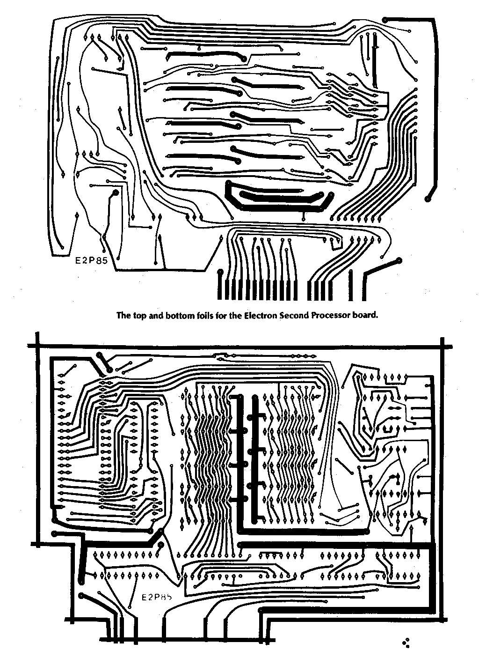
ELECTRON
SECOND
PROCESSOR
It doesn't take ESP to know that we're dealing with the software for John Wike's Electron add-on.

Having described the hardware for this project last month, it is now time to consider the software. When RUN the program creates a 2K machine code file on tape or disc called E2PCODE. This latter is what must be *RUN to operate the second processor. Alternatively, if you have a disc it can be renamed as !BOOT and run using shift-break.
The listing given in this article has been produced using a formatting program to line it up nicely. If you intend to enter it yourself you must leave out all the spaces (except those after the'.' |abels) or it will not fit into memory.

Address I/O (2P) Function Possible Values

800D(FF0D) h Pass Instruction to 2P 8 h Start memory read(0)
9 h Start memory write(1)
C h Run program(4)
28 h Stop memory read/write
40 h Handle Event code
80 h Pass BRK error message
C0 h Set/Reset Escape flag
FF h Initialise 2P (Reset)

8013(FF13) h Pass OS call to I/O LSB Address of I/O OS routine

8014(FF14) h Flush Oswrch buffer flag Equal to 801E(FF1E) h

8019(FF19) h Status for I/O to2P 40 h Data is text
80 h Data is not text
C0 h End of data
801A(FF1A) h Data for I/O to 2P

801B(FF1B) h Status for 2P to I/O As for 8019(FF19) h
801C(FF1C) h Data for 2P to I/O

801D(FF1D) h Oswrch buffer remove pointer Pointers equal if buffer empty
801E(FF1E) h Oswrch buffer insert pointer “

Table 1. Communication protocols.
The beauty of the Acorn machines is that in order to intercept the input/output operations of any language it is only necessary to modify eleven well-documented operating system (OS) routines. Detailed descriptions of these can be found 'The Acorn Electron Advanced User Guide' by Holmes and Dickens, and 'The Advanced User Guide for the BBC Micro' by Bray, Dickens, Holmes. The operating system calls are the same for both machines and while one book also covers the special hardware in the Electron, the other is more readily in the shops.

Memory Usage
In this article the Electron processor will be referred to as the I/O processor because that is its function in the new environment. The second processor will be called 2P for short.
The E2PCODE program loads intp addresses 2800h to 2FFFh in the I/O memory, as shown in the map. This is below the highest resolution screen. It uses memory (again I/O) at 0 to 70h and 400h to 40Bh so it is important that no user programs corrupt these three areas of I/O memory.
The main program is in three sections. Lines 190 to 4880 run where they are in I/O memory. Lines 5930 to 7250 are copied to the 256 byte sideways ROM area and exist at 8000h in I/O memory and FF00h in 2P memory. Finally, lines 7300 to 11100 are passed to 2P memory at F800h to FAFFh.

Communication
The processors communicate with each other by way of various locations in 2P RAM which are used as status and data registers. Their functions are listed in Table 1 and, together with the 28byte Oswrch buffer, they overwrite the 2P reset routine in lines 6020 to 6230. As
there is no hard reset that routine is not needed again anyway. With all the registers, except the buffer pointers, a zero value indicates that the message data has been received and acted on.

Facilities
This implementation has the ability to reset into the I/O processor by pressing B-break, ie hold down the B key while pressing BREAK. Programs can then be developed in the I/O memory without switching off. In I/O HIMEM is set to 2800h to protect the program. In 2P HIMEM is 8000h and PAGE is 800h.
If you execute *HELP while in 2P you will get the message "E2P 0.1". This does not appear if you are in the I/O.
Just one word of warning. Do not use any EVENT handlers in 2P that call OS routines. If you do the system will most probably hang up.
You will have to find out by trial and error which programs will work with a second processor. Anything that accesses screen memory or hardware directly will not work, since this can only be done by OS commands across the interface.

HOW IT WORKS

I/O OPERATION

When the program is run the I/O pro-cessor enters the cold start routine at line 1250. At lines 1350 to 1630 it checks each ROM number from 7 down to 0 for a block of RAM of 256 bytes or less. If it finds one it assumes that it is the E2P card and stores the ROM number in location 'this ROM', if not it returns to the language ROM and prints the error query, ??.
If the ROM is not logged in already (1640-1670), it then cycles through the RAM (1690-1720), loads the RAM (1740-1770) and clears the 2P reset (1780). The RAM is then cycled to refresh it (1800-1820) until the 2P signals that it is ready (1830-1840). It then initiates a 2P memory write and transfers the 2P operating system routines over (1860-2040) before soft resetting itself (2050).
During I/O reset the operating system calls the sideways ROM service routines at 8003h (line 5940) with the Tube reset code FEh in the accumulator. This is detected at line 2350 and the Osbyte vector is changed (2480-2570) to allow the new routine (3000-3140) to set HIMEM and inhibit the memory clear facility. Lines 2590-2670 check for the B key (64h in line 2630). If it is not pressed the Tube presence at Osbyte EAh and the IO/second processor flag at isec are set. The 2P is initialised (2700-2740). The vectors are changed, the soft character set is exploded, the filing system status is set and the sign on message is printed (2670-2920) before leaving the service routine.
Before the I/O can communicate with the 2P it must select the correct sideways ROM location. This is done with the routine at 3230-3320.
If the Tube presence flag is set during I/O reset the operating system will not start up a language but will jump instead to location 400h. This has been loaded at line 2690 (via lines 380-430) with the code in lines 210-240. So it will enter the warm start routines at line 4120. Pointers are set up to transfer the current language to 2P memory either at 8000h (4130-4180) or at a specified relocation address (4190-4300). If the language has been selected by a * command (4320), or if this is a cold start (4330-4340), or if it is a hard reset (4350-4370), and it is not Plus One control ROM at 0Ch (4380-4410), then the language will be transferred to 2P memory (4430-4550). The language will then be started up in 2P by issuing a Run Program command (4590-4680).
The actual routines to give instructions to 2P start at line 3340. The operating system will enter these via the relocated line 230 at 406h, but they are called directly within this program. Lines 3340-3500 allow different filing systems to claim the 2P interface by entering with their Tube ID number plus C0h in the accumulator and waiting for the carry flag to be set. They release the interface using 80h plus the ID number. The read, write and run instructions (0, 1 and 4 respectively) enter with YX pointing to four consecutive locations which hold the action address for the 2P. This address is sent in lines 3550-3660 then the actual instruction number Ored with 8 so that it cannot be zero is sent (3690-3710). If the instruction is to run a program, the I/O processor will enter its main loop, otherwise it will return (3740-3820).
The main loop routine (5540-5880) maintains the rotating Oswrch buffer remove pointer at 801D(FF1D)h. If the buffer is not empty its contents are printed. If it is empty the status register at 8013(FF13)h is examined and an OS call is executed if desired.

2P OPERATION

When the 2P reset is cleared it jumps via its reset vector at FFFCh (7240) to line 6020. Here it loads a 128 byte RAM refresh routine twice into FB00h to FBFFh. This consists of 'compare accumulator immediate' instructions (C9h), which are two bytes long and take two cycles to execute. Thus it will access 128 bytes in 128 cycles, or 64 microseconds. The last few bytes of the routine contain lines 6170-6230 which modify the calling routine to scan the other 128 bytes next time round (6170-6190) and check the status register at 800D(FFOD) h to see if any instructions need to be executed.
Normally the NMI routine (6400-6420) will call the cycle routine (6350-6380) to perform the refresh. However while the I/O is writing or reading 2P memory via the data register at FCE5(FEE5)h the 2P must respond quickly to the IRQ line. So the NMI is disabled and the 2P goes into the loop (6680-6700) where it is continually cycling to do the refresh. The read/write function is performed by modifying the three locations at ivec (6270) in the irql routine (6250-6330) to read or write the specified start address (6470-6550). If it is a read the first location is read by a software interrupt (6610-6620).
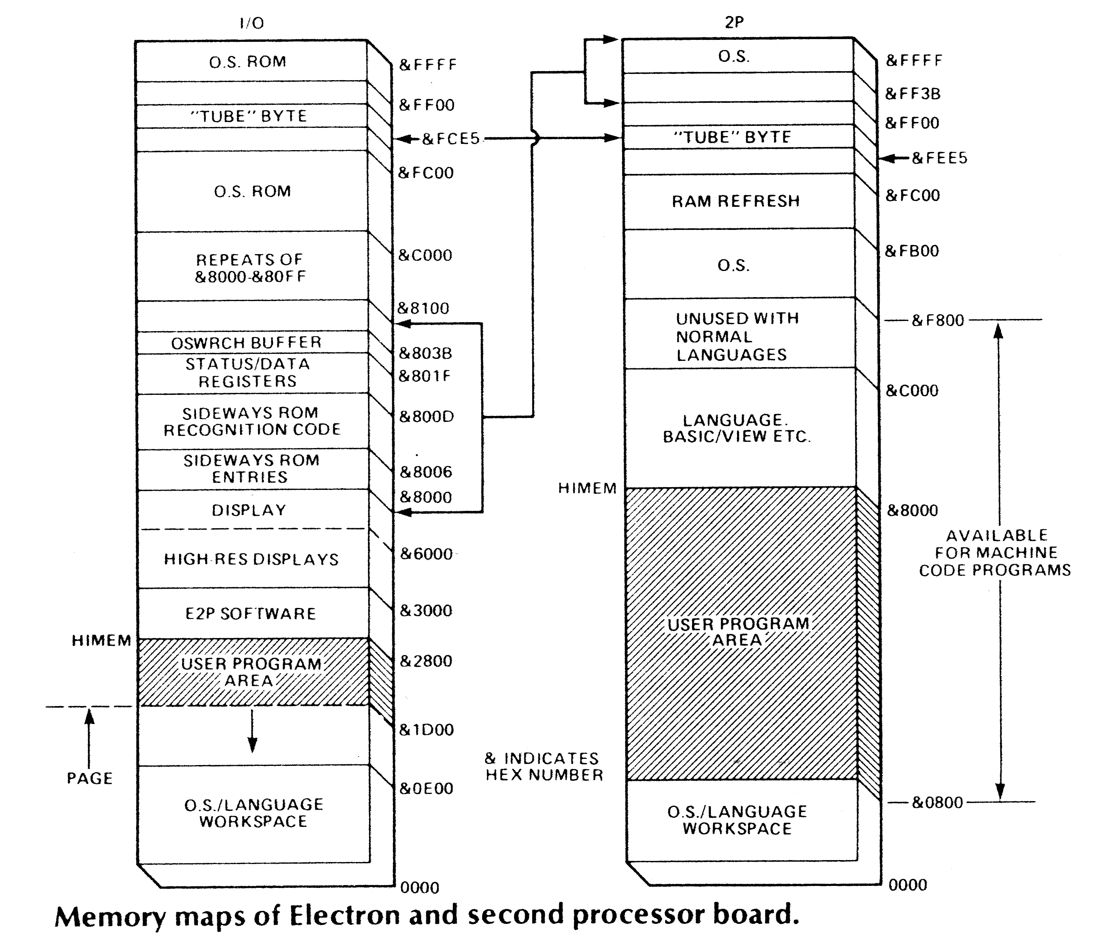
The other instructions are looked for in the test routines (7460-8310) and the appropriate action taken. The 2P OS routines (8330-9720) interact with their I/O counterparts (450-1230) via the register at 8013(FF13)h. Some routines need to pass over the processor A,X and Y registers. Some need to pass text and some need block data. These are handled by the routines at lines 4700-5360, 6730-6780, and 9740-10320. The Osword routines transfer different amounts of different size blocks. The tables at 10480-10910 are
used to determine how much to send.
The 2P Osbyte routine checks for the memory functions 82h to 84h (8420-8540). these give the machine high order address (FFFFh for I/O, 0000h for 2P), PAGE, HIMEM, and HIMEM in other Modes, in that order. It also checks (8560-8640) whether the Oswrch buffer is being flushed (Osbyte DAh,0,0) and sets the flag at 8014(FF14)h.

Listing of Electron program to run second processor. Copyright John Wike, 1985.

50 REM AS SPACE IS SHORT WHEN
60 REM USING DISCS, THE CODE IS
70 REM ASSEMBLED INTO SCREEN
80 REM MEMORY BEFORE SAVING.
90 :
100 MODE6:VDU28,0,24,39,12
110 :
120 rgX=&F0:txt=&F2:rpl=&F4
130 blk=&96:num=&98:tmp=&99
140 cmd=&9A
150 :
160 U%=&2800:V%=&6500:HIMEM=V%
170 A%=U%:B%=U%
180 FOR I=4TO6STEP2
190 O%=V%:P%=U%
200 [OPT I
210 JMP cold
220 :
230 .cod400
240 JMP warm
250 JMP esc
260 JMP instr
270 .osjmp
280 JMP osrdch
290 :
300 .pload
310 LDA (0),Y
320 INC 0
330 BNE pload2
340 INC 1
350 :
360 .pload2
370 STA &FCE5
380 :
390 LDY #7
400 .delay
410 DEY
420 BNE delay
430 RTS
440 :
450 .codld
460 LDX #&C
470 .codld5
480 LDA cod400-1,X
490 STA &3FF,X
500 DEX
510 BNE codld5
520 RTS
530 :
540 .osrdch
550 JSR &FFE0
560 .osrd1
570 JSR regso2
580 .osret
590 LDA #0
600 STA &8013
610 .anrts
620 RTS
630 :
640 .oscli
650 JSR datin
660 JSR &FFF7
670 JMP osret
680 :
690 .osbyte
700 JSR regsin
710 JSR &FFF4
720 JSR regsout
730 JMP osret
740 :
750 .osword
760 LDA &8016
770 BNE oswd5
780 JSR datin
790 STX 0
800 STY 1
810 TXA
820 TAY
830 JSR &FFF1
840 JSR regso3
850 JSR osret
860 BCS anrts
870 JMP txtout
880 :
890 .oswd5
900 LDY #&20
910 JSR datin1
920 LDX #&20
930 LDY #0
940 LDA &8016
950 JSR &FFF1
960 JSR osret
970 JSR regsin
980 JMP blkout2
990 :
1000 .osargs
1010 JSR datin
1020 JSR regsi1
1030 JSR &FFDA
1040 JSR osrd1
1050 JMP blkout
1060 :
1070 .osbget
1080 JSR regsi1
1090 JSR &FFD7
1100 JMP osrd1
1110 :
1120 .osbput
1130 JSR regsi1
1140 JSR &FFD4
1150 JMP osret
1160 :
1170 .osfind
1180 JSR regsi1
1190 BEQ osf5
1200 PHA
1210 JSR datin
1220 PLA
1230 .osf5
1240 JSR &FFCE
1250 JMP osrd1
1260 :
1270 .osfile
1280 JSR datin
1290 JSR datin
1300 STX 0
1310 STY 1
1320 LDY #0
1330 LDA &8016
1340 JSR &FFDD
1350 JSR osrd1
1360 LDX #&12
1370 LDY #2
1380 JMP blkout2
1390 :
1400 .osgbpb
1410 JSR datin
1420 LDY #0
1430 LDA &8016
1440 JSR &FFD1
1450 JSR osrd1
1460 LDX #&D
1470 JMP blkout1
1480 :
1490 .cold
1500 SEI
1510 LDA #&40
1520 STA &D00
1530 LDA #&AA
1540 LDX #0
1550 LDY #&FF
1560 JSR &FFF4
1570 STX &F6
1580 STY &F7
1590 :
1600 LDX &F4
1610 LDY #7
1620 .cold1
1630 TYA
1640 JSR sidesel
1650 LDA &8000
1660 CMP &8100
1670 BNE cold5
1680 EOR #&FF
1690 STA &8000
1700 CMP &8100
1710 PHP
1720 EOR #&FF
1730 STA &8000
1740 PLP
1750 BEQ cold7
1760 :
1770 .cold5
1780 DEY
1790 BPL cold1
1800 TXA
1810 JSR sidesel
1820 BRK
1830 BRK
1840 EQUS "No E2P"
1850 BRK
1860 :
1870 .coldvec
1880 EQUW tclear
1890 :
1900 .cold7
1910 STY thisROM
1920 LDA (&F6),Y
1930 BEQ cold10
1940 CMP &8006
1950 BEQ cold16
1960 :
1970 .cold10
1980 LDX #0
1990 .cold11
2000 LDA &8000,X
2010 INX
2020 BNE cold11
2030 :
2040 .cold12
2050 LDA B%,X
2060 STA &8000,X
2070 INX
2080 BNE cold12
2090 LDA &FCE5
2100 :
2110 .cold15
2120 LDA &8000,X
2130 INX
2140 BNE cold15
2150 LDA &800D
2160 BNE cold15
2170 :
2180 .cold16
2190 LDX #coldvec MOD 256
2200 LDY #coldvec DIV 256
2210 LDA #1
2220 JSR instr
2230 :
2240 LDA #C% MOD 256:STA 0
2250 LDA #C% DIV 256:STA 1
2260 LDY #0
2270 STY langflg
2280 :
2290 .cold17
2300 JSR pload
2310 LDA 0
2320 CMP #D% MOD 256
2330 BNE cold17
2340 LDA 1
2350 CMP #D% DIV 256
2360 BNE cold17
2370 JMP (&FFFC)
2380 :
2390 .message1
2400 EQUB &D
2410 EQUS "E2P 0.10"
2420 EQUB &D
2430 EQUB 0
2440 :
2450 .message2
2460 EQUS "SECOND PROCESSOR"
2470 EQUB &D
2480 EQUB &D
2490 EQUB 0
2500 :
2510 .prnmes
2520 LDX #0
2530 .prnmes2
2540 LDA message1,X
2550 BEQ prnmes5
2560 JSR &FFE3
2570 INX
2580 BNE prnmes2
2590 .prnmes5
2600 RTS
2610 :
2620 .Rserv
2630 CPX thisROM
2640 BNE Rserv3
2650 :
2660 CMP #9
2670 BNE Rserv2
2680 BIT isec
2690 BPL Rserv2
2700 JSR prnmes2
2710 LDA #9
2720 :
2730 .Rserv2
2740 CMP #&FE
2750 .Rserv3
2760 BNE Rserv15
2770 :
2780 TYA
2790 PHA
2800 JSR &FFE7
2810 LDA #&A6
2820 LDX #0
2830 LDY #&FF
2840 JSR &FFF4
2850 STX &1D
2860 STY &1E
2870 :
2880 LDA &20B
2890 CMP #newosb DIV 256
2900 BEQ Rserv5
2910 STA oldosb+1
2920 LDA &20A:STA oldosb+0
2930 LDA #newosb DIV 256:STA &20B
2940 LDA #newosb MOD 256:STA &20A
2950 :
2960 .Rserv5
2970 LDA #&7A
2980 JSR &FFF4
2990 LDY #0
3000 STY isec
3010 CPX #&64
3020 BNE Rserv7
3030 LDA #&78
3040 JSR &FFF4
3050 JMP Rserv10
3060 :
3070 .Rserv7
3080 JSR codld
3090 LDA #&FF
3100 STA isec
3110 LDY #&EA
3120 STA (&1D),Y
3130 JSR pcomm
3140 :
3150 LDA #brk MOD 256:STA &202
3160 LDA #brk DIV 256:STA &203
3170 LDA #event MOD 256:STA &220
3180 LDA #event DIV 256:STA &221
3190 :
3200 LDA #&14
3210 LDX #6
3220 JSR &FFF4
3230 LDA #&80
3240 STA &14
3250 :
3260 LDX #message2-message1
3270 JSR prnmes2
3280 :
3290 .Rserv10
3300 PLA
3310 TAY
3320 LDA #0
3330 .Rserv15
3340 LDX &F4
3350 RTS
3360 :
3370 .newosb
3380 CMP #&84
3390 BEQ newosb2
3400 CMP #&85
3410 BNE newosb5
3420 .newosb2
3430 LDX #A% MOD 256
3440 LDY #A% DIV 256
3450 RTS
3460 :
3470 .newosb5
3480 CMP #&C8
3490 BNE newosb7
3500 TXA
3510 AND #&FD
3520 TAX
3530 LDA #&C8
3540 .newosb7
3550 JMP (oldosb)
3560 :
3570 .pcomm
3580 STA &800D
3590 .pstat
3600 NOP
3610 NOP
3620 LDA &800D
3630 BNE pstat
3640 RTS
3650 :
3660 .pselect
3670 LDA thisROM
3680 JSR sidesel
3690 JMP pstat
3700 :
3710 .sidesel
3720 STA &F4
3730 LDA #&C
3740 STA &FE05
3750 LDA &F4
3760 STA &FE05
3770 RTS
3780 :
3790 .instr
3800 CMP #&80
3810 BCC instr4
3820 CMP #&C0
3830 BCC instr3
3840 ASL &14
3850 BCS instr1
3860 CMP &15
3870 BEQ instr2
3880 CLC
3890 RTS
3900 .instr1
3910 STA &15
3920 .instr2
3930 RTS
3940 .instr3
3950 ORA #&40
3960 CMP &15
3970 BNE instr2
3980 LDA #&80
3990 STA &14
4000 LDA #&20
4010 :
4020 .instr4
4030 PHP
4040 SEI
4050 STY &13
4060 STX &12
4070 STA &16
4080 LDA &F4
4090 PHA
4100 JSR pselect
4110 :
4120 LDY #1
4130 .instr5
4140 LDA (&12),Y
4150 STA &8010,Y
4160 DEY
4170 BPL instr5
4180 :
4190 LDY &13
4200 LDA &16
4210 ORA #8
4220 .instr7
4230 JSR pcomm
4240 PLA
4250 JSR sidesel
4260 LDA &16
4270 CMP #4
4280 BNE instr9
4290 :
4300 .instr8
4310 LDA #&80
4320 STA &14
4330 JMP main
4340 .instr9
4350 PLP
4360 RTS
4370 :
4380 .esc
4390 PHP
4400 SEI
4410 LDA &F4
4420 PHA
4430 JSR pselect
4440 LDA &FF
4450 STA &8010
4460 LDA #&C0
4470 STA &16
4480 BNE instr7
4490 :
4500 .event
4510 STA &19
4520 PHP
4530 LDA &F4
4540 PHA
4550 JSR pselect
4560 STX &800E
4570 STY &800F
4580 LDA &19
4590 STA &8010
4600 LDA #&40
4610 JSR pcomm
4620 PLA
4630 JSR sidesel
4640 LDA &19
4650 PLP
4660 RTS
4670 :
4680 .warm
4690 CLI
4700 LDY #0
4710 STY 0
4720 STY &17
4730 LDA #&80
4740 STA 1
4750 STA &18
4760 LDA #&20
4770 AND &8006
4780 BEQ warm2
4790 :
4800 LDX &8007
4810 .warm1
4820 INX
4830 LDA &8000,X
4840 BNE warm1
4850 LDA &8001,X
4860 STA &17
4870 LDA &8002,X
4880 STA &18
4890 :
4900 .warm2
4910 BCS warm4
4920 BIT langflg
4930 BPL warm4
4940 LDY #&FD
4950 LDA (&1D),Y
4960 BEQ warm99
4970 .warm4
4980 LDA &F4
4990 CMP #&C
5000 BNE warm5
5010 JMP &8000
5020 :
5030 .warm5
5040 LDA #1
5050 JSR warm100
5060 .warm7
5070 JSR pload
5080 BIT 1
5090 BVS warm12
5100 :
5110 .warm10
5120 LDA 0
5130 CLC
5140 ADC &17
5150 LDA 1
5160 ADC &18
5170 CMP #&F8
5180 BCC warm7
5190 :
5200 .warm12
5210 LDA #&FF
5220 STA langflg
5230 .warm99
5240 LDA #4
5250 :
5260 .warm100
5270 PHA
5280 .warm110
5290 LDA #&FF
5300 JSR instr
5310 BCC warm110
5320 PLA
5330 LDX #&17
5340 LDY #0
5350 JMP instr
5360 :
5370 .regsout
5380 STY &8018
5390 .regso1
5400 STX &8017
5410 .regso2
5420 STA &8016
5430 .regso3
5440 ROL A
5450 STA &8015
5460 ROR A
5470 RTS
5480 :
5490 .regsin
5500 LDX &8017
5510 .regsi1
5520 LDY &8018
5530 LDA &8016
5540 RTS
5550 :
5560 .datin
5570 LDY #0
5580 .datin1
5590 LDX #0
5600 .datin2
5610 BIT &8019
5620 BVC datin5
5630 BMI datin9
5640 LDA &801A
5650 STA &700,Y
5660 BVS datin7
5670 :
5680 .datin5
5690 BPL datin2
5700 CPY #&12
5710 BCC datin6
5720 CPY #&20
5730 BCC datin7
5740 CPY #&70
5750 BCS datin7
5760 :
5770 .datin6
5780 LDA &801A
5790 STA 0,Y
5800 .datin7
5810 CLV
5820 .datin9
5830 STX &8019
5840 INY
5850 BVC datin2
5860 LDY #7
5870 RTS
5880 :
5890 .blkout
5900 LDX #4
5910 .blkout1
5920 LDY #0
5930 .blkout2
5940 STX &1A
5950 .blkout3
5960 LDX #&80
5970 .blkout5
5980 CPY &1A
5990 BEQ txtout5
6000 LDA 0,Y
6010 JSR datout
6020 INY
6030 BNE blkout5
6040 :
6050 .txtout
6060 LDX #&40
6070 LDY #0
6080 .txtout2
6090 LDA &700,Y
6100 JSR datout
6110 INY
6120 CMP #&D
6130 BNE txtout2
6140 .txtout5
6150 LDX #&C0
6160 :
6170 .datout
6180 NOP
6190 NOP
6200 BIT &801B
6210 BVS datout
6220 BMI datout
6230 STA &801C
6240 STX &801B
6250 RTS
6260 :
6270 .brk
6280 LDY #&FF
6290 .brk2
6300 INY
6310 LDA (&FD),Y
6320 STA &20,Y
6330 TAX
6340 BNE brk2
6350 TYA
6360 BEQ brk2
6370 INY
6380 STY &1A
6390 LDY #&20
6400 JSR pselect
6410 LDA #&80
6420 JSR pcomm
6430 JSR blkout3
6440 :
6450 .main
6460 LDX #&FF
6470 TXS
6480 .main2
6490 SEI
6500 LDA thisROM
6510 JSR sidesel
6520 CLI
6530 .main3
6540 LDX &8014
6550 BEQ main4
6560 STX &801D
6570 LDA #0
6580 STA &8014
6590 :
6600 .main4
6610 LDX &801D
6620 CPX &801E
6630 BEQ main9
6640 :
6650 INX
6660 CPX #vduend MOD 256
6670 BCC main7
6680 LDX #vdustart MOD 256
6690 .main7
6700 LDA &8000,X
6710 STX &801D
6720 JSR &FFEE
6730 JMP main3
6740 :
6750 .main9
6760 LDA &8013
6770 BEQ main2
6780 :
6790 LDX &801D
6800 CPX &801E
6810 BNE main3
6820 :
6830 STA osjmp-cod400+&401
6840 JSR osjmp-cod400+&400
6850 JMP main
6860 ]
6870 B%=O%-V%+U%
6880 P%=&FF00
6890 vdustart=&FF1F
6900 [OPT I \ 2P Client code
6910 JMP warm
6920 JMP Rserv
6930 EQUB &82
6940 EQUB 8
6950 EQUB 0
6960 EQUS "(C)"
6970 EQUB 0
6980 EQUB &FF
6990 :
7000 .reset
7010 LDX #&FF
7020 TXS
7030 .reset2
7040 LDA refresh-&FF,X
7050 .reset4
7060 STA &FB00,X \ Copy refresh code
7070 STA &FA80,X
7080 DEX
7090 CMP #&C9
7100 BNE reset2
7110 DEX
7120 BMI reset4
7130 LDA #hostcmd7 MOD 256
7140 STA &FFFC \ Redirect Reset
7150 BNE hostcmd7
7160 :
7170 CMP #0
7180 LDA cycle+1
7190 EOR #&80
7200 STA cycle+1
7210 LDA &FF0D \ Get host command
7220 CMP cmd \ Check if changed
7230 STA cmd
7240 .refresh
7250 RTS
7260 .vduend \ End of VDU queue
7270 :
7280 .irq \ Called by &FEE5 a
ccess
7290 PHA
7300 LDA &FEE5 \ Get byte
7310 .ivec
7320 STA &200 \ Store or fetch
7330 STA &FEE5 \ Send byte
7340 INC ivec+1 \ Update address
7350 BNE irqexit
7360 INC ivec+2
7370 .irqexit
7380 PLA
7390 .anrti
7400 RTI
7410 :
7420 .cycle
7430 JSR &FB00
7440 BEQ cycle5 \ No change
7450 ORA #0
7460 .cycle5
7470 RTS
7480 :
7490 .nmi \ Called every 1ms
7500 PHA
7510 JSR cycle \ Refresh RAM
7520 BEQ irqexit \ No host command
7530 :
7540 .hostcmd
7550 CMP #9
7560 BCC hostcmd2 \ cmd=8, save mem
7570 BNE hostcmd10 \ cmd<>9
7580 LDA #&8D \ cmd=9, load mem
7590 BNE hostcmd4 \ opcode=STA
7600 :
7610 .hostcmd2
7620 LDA #&AD \ opcode=LDA
7630 .hostcmd4
7640 STA ivec
7650 LDA &FF10 \ Get transfer add
7660 STA ivec+1
7670 LDA &FF11
7680 STA ivec+2
7690 :
7700 LDA #irq MOD 256
7710 STA &FFFE \ Set IRQ vector
7720 LDA #anrti MOD 256
7730 STA &FFFA \ Ignore NMIs
7740 BCS hostcmd6
7750 BRK \ Trigger P->H
7760 NOP
7770 :
7780 .hostcmd6
7790 CLI
7800 .hostcmd7
7810 LDA #0
7820 STA &FF0D
7830 .hostcmd8
7840 JSR cycle
7850 BNE hostcmd \ Process command
7860 BEQ hostcmd8 \ Loop back
7870 .hostcmd10
7880 JMP hostcmd12
7890 :
7900 .regsin10
7910 LDY &FF18
7920 .regsin11
7930 LDX &FF17
7940 .regsin12
7950 LDA &FF15
7960 ROR A
7970 LDA &FF16
7980 RTS
7990 :
8000 .irq5
8010 STA &FC
8020 PLA
8030 ORA #4
8040 PHA
8050 AND #&10
8060 BEQ irq7 \ Not BRK, exit
8070 :
8080 TXA
8090 PHA
8100 TSX
8110 LDA &103,X \ Pop address
8120 CLD
8130 SEC
8140 SBC #1
8150 STA &FD
8160 LDA &104,X
8170 SBC #0
8180 STA &FE
8190 PLA
8200 TAX
8210 LDA &FC
8220 JMP (&202) \ Jump to BRKV
8230 .irq7
8240 LDA &FC
8250 RTI
8260 :
8270 .evjmp
8280 JMP (&220)
8290 :
8300 JMP (&21C)
8310 JMP (&21A)
8320 JMP (&218)
8330 JMP (&216)
8340 JMP (&214)
8350 JMP (&212)
8360 JMP (&210)
8370 CMP #&D
8380 BNE &FFEE
8390 LDA #&A
8400 JSR &FFEE
8410 LDA #&D
8420 JMP (&20E)
8430 JMP (&20C)
8440 JMP (&20A)
8450 JMP (&208)
8460 EQUW anrti
8470 EQUW reset
8480 EQUW anrti
8490 ]
8500 C%=O%-V%+U%
8510 P%=&F800
8520 [OPT I
8530 .tclear
8540 LDA &FF1E \ Clear VDU queue
8550 STA &FF14
8560 LDA #0
8570 STA &FF13 \ Clear command
8580 STA &FF19 \ Clear status
8590 STA &FF1B \ Clear status
8600 :
8610 .tclear10
8620 LDA #irq5 MOD 256
8630 STA &FFFE
8640 LDA #nmi MOD 256
8650 STA &FFFA
8660 :
8670 .tclear20
8680 LDA #0
8690 STA &FF0D
8700 RTS
8710 :
8720 .hostcmd12
8730 CMP #&C
8740 BNE hostcmd15 \ Not execute
8750 LDX #&FF
8760 TXS \ Reset stack
8770 LDA &FF11 \ Get address
8780 PHA
8790 STA osbtab+2 \ Set memtop
8800 STA osbtab+3
8810 LDA &FF10
8820 PHA
8830 SEI
8840 PHP
8850 JSR tclear
8860 LDA #1
8870 RTI \ Jump to code
8880 :
8890 .hostcmd15
8900 CMP #&28
8910 BEQ hostcmd92 \ Start/stop
8920 BCC hostcmd92
8930 :
8940 CMP #&FF
8950 BNE hostcmd20 \ Not reset
8960 TAX
8970 TXS \ Clear stack
8980 INX
8990 STX &FF
9000 LDX #&23
9010 STX &FF1E \ Clear VDU queue
9020 .hostcmd17
9030 LDA vectab,X \ Init vectors
9040 STA &200,X
9050 DEX
9060 BPL hostcmd17
9070 :
9080 .hostcmd18A
9090 JSR tclear
9100 .hostcmd18
9110 JMP hostcmd18 \ Wait for NMI/IRQ
9120 :
9130 .hostcmd20
9140 CMP #&C0
9150 BNE hostcmd25 \ Not escape
9160 LDA &FF10
9170 STA &FF \ Set escflg
9180 BMI hostcmd92 \ Clear VDU queue
9190 :
9200 .hostcmd90
9210 LDA &FFFA
9220 CMP #anrti MOD 256
9230 BNE hostcmd95
9240 JMP hostcmd7
9250 :
9260 .hostcmd92
9270 JSR tclear10
9280 PLA
9290 RTI
9300 :
9310 .hostcmd95
9320 JSR tclear20
9330 PLA
9340 RTI
9350 :
9360 .hostcmd25
9370 CMP #&40
9380 BNE hostcmd30 \ Not event
9390 TXA
9400 PHA
9410 TYA
9420 PHA
9430 LDX &FF0E \ Get regs
9440 LDY &FF0F
9450 LDA &FF10
9460 JSR evjmp
9470 PLA
9480 TAY
9490 PLA
9500 TAX
9510 JMP hostcmd90
9520 :
9530 .hostcmd30 \ Host BRK
9540 TXA
9550 PLA
9560 PHA
9570 PHA
9580 JSR tclear
9590 LDX #0
9600 STX &FD
9610 LDY #&FD
9620 STY &FE
9630 JSR datin10
9640 PLA
9650 TAY
9660 PLA
9670 TAX
9680 PLA
9690 STA &FC
9700 JMP (&202)
9710 :
9720 .rdch
9730 LDA #osrdch MOD 256
9740 JSR oscomm
9750 JMP regsin12
9760 :
9770 .cli
9780 LDA #oscli MOD 256
9790 STA &FF13
9800 JSR txtout10
9810 JMP osstat
9820 :
9830 .byte
9840 CMP #&82
9850 BCC byte15
9860 CMP #&86
9870 BCS byte15
9880 TAX
9890 LDY osbtab-&82,X
9900 LDX #0
9910 .anrts
9920 RTS
9930 :
9940 .osbtab
9950 EQUB 0
9960 EQUB 8
9970 EQUB &80
9980 EQUB &80
9990 :
10000 .byte15
10010 CMP #&DA
10020 BNE byte20
10030 TXA
10040 BNE byte18
10050 TYA
10060 BNE byte18
10070 LDA &FF1E
10080 STA &FF14
10090 .byte18
10100 LDA #&DA
10110 .byte20
10120 JSR regso10
10130 LDA #osbyte MOD 256
10140 JSR oscomm
10150 JMP regsin10
10160 :
10170 .word
10180 STA &FF16
10190 LDA #osword MOD 256
10200 STA &FF13
10210 LDA &FF16
10220 BNE oswd15
10230 LDA #5
10240 JSR blkout10
10250 JSR osstat
10260 JSR regsin12
10270 BCS anrts
10280 LDY #0
10290 LDA (blk),Y
10300 TAX
10310 INY
10320 LDA (blk),Y
10330 TAY
10340 JMP datin10
10350 :
10360 .oswd15
10370 STX rgX
10380 CMP #&E
10390 BCC oswd17
10400 LDA #&E
10410 :
10420 .oswd17
10430 TAX
10440 LDA oswifrm-1,X
10450 STA &FF18
10460 LDA oswito-1,X
10470 STA &FF17
10480 LDA oswoto-1,X
10490 LDX rgX
10500 JSR blkout10
10510 JSR osstat
10520 LDA &FF18
10530 AND #&1F
10540 JSR datin11
10550 JMP blkout19
10560 :
10570 .args
10580 JSR regso10
10590 LDA #osargs MOD 256
10600 STA &FF13
10610 LDY #0
10620 LDA #4
10630 CLD
10640 JSR blkout10
10650 JSR osstat
10660 JSR datin10
10670 JMP regsin10
10680 :
10690 .bget
10700 STY &FF18
10710 LDA #osbget MOD 256
10720 .bget12
10730 JSR oscomm
10740 JMP regsin12
10750 :
10760 .bput
10770 JSR regso11
10780 LDA #osbput MOD 256
10790 BNE bget12
10800 :
10810 .find
10820 JSR regso10
10830 PHA
10840 LDA #osfind MOD 256
10850 STA &FF13
10860 PLA
10870 BEQ find20
10880 JSR txtout10
10890 :
10900 .find20
10910 JSR osstat
10920 JMP regsin10
10930 :
10940 .file
10950 STA &FF16
10960 LDA #osfile MOD 256
10970 STA &FF13
10980 LDA #&12
10990 JSR blkout10
11000 LDY #0
11010 LDA (blk),Y
11020 TAX
11030 INY
11040 LDA (blk),Y
11050 TAY
11060 JSR txtout10
11070 JSR osstat
11080 LDX blk
11090 LDY blk+1
11100 LDA #2
11110 .file15
11120 JSR datin11
11130 LDX blk
11140 LDY blk+1
11150 JMP regsin12
11160 :
11170 .gbpb
11180 STA &FF16
11190 LDA #osgbpb MOD 256
11200 STA &FF13
11210 LDA #&D
11220 JSR blkout10
11230 JSR osstat
11240 CLD
11250 LDA #0
11260 BEQ file15
11270 :
11280 .oscomm
11290 STA &FF13
11300 .osstat
11310 LDA &FF13
11320 BNE osstat
11330 RTS
11340 :
11350 .regso10
11360 STX &FF17
11370 .regso11
11380 STY &FF18
11390 STA &FF16
11400 RTS
11410 :
11420 .txtout10
11430 STX txt
11440 STY txt+1
11450 LDX #&40
11460 LDY #0
11470 .txtout12
11480 LDA (txt),Y
11490 JSR datout10
11500 INY
11510 CMP #&D
11520 BNE txtout12
11530 .txtout15
11540 LDX #&C0
11550 :
11560 .datout10
11570 BIT &FF19
11580 BVS datout10
11590 BMI datout10
11600 STA &FF1A
11610 STX &FF19
11620 .datout15
11630 RTS
11640 :
11650 .blkout10
11660 STA num
11670 .blkout11
11680 STX blk
11690 STY blk+1
11700 LDX #&80
11710 LDY #0
11720 .blkout15
11730 CPY num
11740 BEQ blkout17
11750 LDA (blk),Y
11760 JSR datout10
11770 INY
11780 BNE blkout15
11790 :
11800 .blkout17
11810 JSR txtout15
11820 .blkout19
11830 LDX blk
11840 LDY blk+1
11850 RTS
11860 :
11870 .datin10
11880 LDA #0
11890 .datin11
11900 STX rpl
11910 STY rpl+1
11920 TAY
11930 LDX #0
11940 .datin12
11950 BIT &FF1B
11960 BVC datin15
11970 BMI datin19
11980 BPL datin17
11990 :
12000 .datin15
12010 BPL datin12
12020 .datin17
12030 LDA &FF1C
12040 STA (blk),Y
12050 CLV
12060 :
12070 .datin19
12080 STX &FF1B
12090 INY
12100 BVC datin12
12110 RTS
12120 :
12130 .wrch
12140 STX tmp
12150 LDX &FF1E
12160 INX
12170 CPX #vduend MOD 256
12180 BCC wrch15
12190 LDX #vdustart MOD 256
12200 .wrch15
12210 CPX &FF1D
12220 BEQ wrch15
12230 :
12240 STA &FF00,X
12250 STX &FF1E
12260 LDX tmp
12270 RTS
12280 :
12290 .oswoto
12300 EQUB 0
12310 EQUB 5
12320 EQUB 0
12330 EQUB 5
12340 EQUB 4
12350 EQUB 5
12360 EQUB 8
12370 EQUB &E
12380 EQUB 4
12390 EQUB 1
12400 EQUB 1
12410 EQUB 5
12420 EQUB 0
12430 EQUB &10
12440 :
12450 .oswifrm
12460 EQUB &20
12470 EQUB &20
12480 EQUB &20
12490 EQUB &20
12500 EQUB &24
12510 EQUB &20
12520 EQUB &20
12530 EQUB &20
12540 EQUB &24
12550 EQUB &21
12560 EQUB &21
12570 EQUB &20
12580 EQUB &20
12590 EQUB &20
12600 :
12610 .oswito
12620 EQUB &25
12630 EQUB &20
12640 EQUB &25
12650 EQUB &20
12660 EQUB &25
12670 EQUB &20
12680 EQUB &20
12690 EQUB &20
12700 EQUB &25
12710 EQUB &29
12720 EQUB &25
12730 EQUB &20
12740 EQUB &28
12750 EQUB &30
12760 :
12770 .vectab
12780 EQUW anrts
12790 EQUW hostcmd18A
12800 EQUW irq7
12810 EQUW irq7
12820 EQUW cli
12830 EQUW byte
12840 EQUW word
12850 EQUW wrch
12860 EQUW rdch
12870 EQUW file
12880 EQUW args
12890 EQUW bget
12900 EQUW bput
12910 EQUW gbpb
12920 EQUW find
12930 EQUW anrts
12940 EQUW anrts
12950 EQUW anrts
12960 :
12970 ]
12980 D%=O%-V%+U%
12990 P%=D%
13000 [OPT I
13010 .langflg
13020 EQUB 0
13030 .isec
13040 EQUB 0
13050 .oldosb
13060 EQUW 0
13070 .thisROM
13080 EQUB 0
13090 ]
13100 NEXT
13110 PRINT"IF YOU ARE USING TAPES,"
13120 PRINT"INSERT CASSETTE THAT WILL H
OLD RUN CODE."
13130 OSCLI"SAVE E2PCODE FFFF"+STR$~V%+
" +"+STR$~(D%-A%)+" FFFF"+STR$~U%+" FFF
F"+STR$~U%
13140 VDU26:CLS

